Kaggle Notebook Guidelines

- Firstly, create an account on Kaggle & then verify phone no. to get GPU Access.
- After that go to home pg. & click on “ + ” icon & then click on import notebook
- Choose link option & paste this link : https://www.kaggle.com/code/sarveshvengurlekar1/kaggle-yolo-model-training-notebook
- After that expand right side sidebar & click on add input
- Choose dataset option & add this dataset name in search bar “Indian Driving Dataset-Detections (YOLOv11)”
- Then click on add button once.
- After that go to top section & click on settings then select 2*t4 gpu option.
- After that run step 1 & make sure you get same o/p as below with 2*T4 GPU
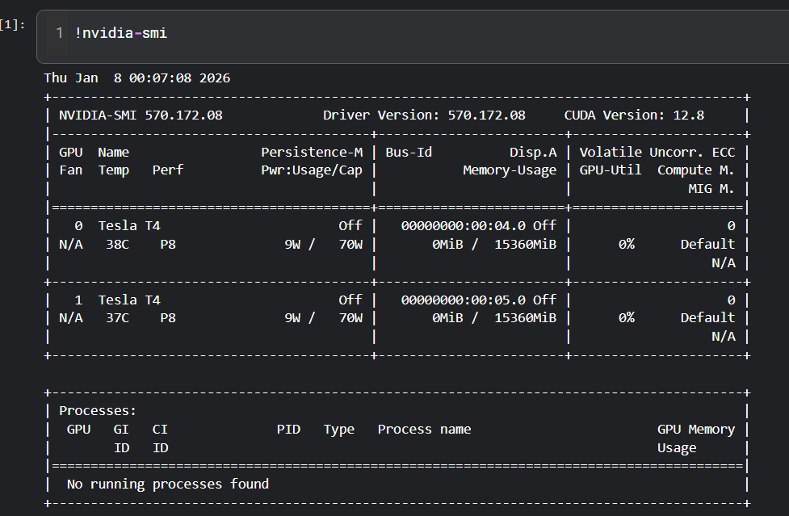

- After run Step 2 & 3
- After that go to right side sidebar.
- Click on upload & then new dataset option.
- Enter dataset title as “kaggle-yaml” & upload
- Run training code cell
1 Epoch = 11 min 30 sec
5 Epoch ~ 1hr.
10 Epoch ~ 2hr.
15 Epoch ~ 3 hr.
20 Epoch ~ 3.8 hr.
- After Training Completion go to right side sidebar
- Click on o/p section
- Refresh Kaggle working dir.
- Download zip file
- Then look for last train file
- In that file go to weights section & see if best & last pt model are there or not.
- After downloading zip file go to Kaggle
- Go to files on top & download notebook
